1. Use gridlines to balance your shot.
One of the easiest and best ways to improve your mobile photos is to turn on the camera's gridlines so you can follow the "rule of thirds" -- a photographic composition principle that says an image should be broken down into thirds, both horizontally and vertically/.
If you place points of interest in these intersections or along the lines, your photo will be more balanced, level, and allow viewers to interact with it more naturally.
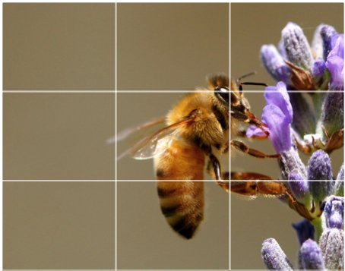
Source: Digital Photography School
To switch the grid on ...
- iPhone: Go to "Settings," choose "Photos & Camera," and switch "Grid" on.
- Samsung Galaxy: Launch the camera app, go to "Settings," scroll down and switch the "grid lines" option to "on."
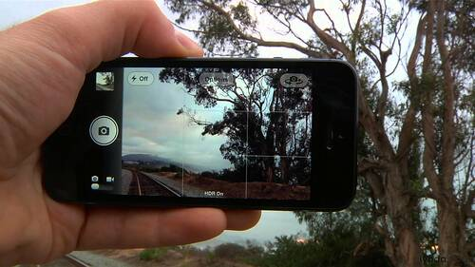
Source: Lynda.com

2. Set your camera's focus.
Today's phone cameras automatically focus on the foreground of your frame, but not every picture you take on your phone has an obvious subject. To adjust where you want your camera lens to focus, tap on the camera screen where you want to sharpen the view.
If you're taking a photo of something in motion, for example, it can be difficult for your camera to follow this subject and refocus as needed. Tap the screen to correct your phone camera's focus just before snapping the picture to ensure the moving subject has as much focus as possible. A square or circular icon should then appear on your camera screen, shifting the focus of your shot to all of the content inside that icon.

3. Focus on one subject.
Many of the best photos include just one, interesting subject. So when taking a picture of one, spend some extra time setting up the shot. Some professional photographers say that the subject shouldn't fill the entire frame, and that two-thirds of the photo should be negative space -- that helps the subject stand out even more. Make sure there aren't any foreign objects in there (trashcans, people that are irrelevant, bags, etc.)
But be sure you tap the screen of your smartphone to focus the camera on your subject -- that'll help to ensure that it's focused and the lighting is optimized.
Pro Tip: Once you've taken your photo, you can use filters and apps to make the subject even more vivid, or to crop it to frame the subject correctly. The brightness, contrast, and saturation of the photo can also be adjusted accordingly -- all from your phone.
Source: Patrick Janelle

4. Embrace negative space.
"Negative space" simply refers to the areas around and between the subjects of an image --and it can take a photo from "good" to "great" as long as the background is contrasting and flattering.
When you include a lot of empty space in a photo, your subject will stand out more and evoke a stronger reaction from your viewer. And what does negative space looks like? It's often a large expanse of open sky, water, an empty field, or a large wall, as in the examples below.
Source: Eric Christian

5. Find different perspectives.
Taking photos from a unique, unexpected angle can make them more memorable -- it tends to create an illusion of depth or height with the subjects. It also makes the image stand out, since most mobile photos are taken either straight -on or from a bird's eye view.
Try taking a photo directly upward and playing with the sky as negative space, like in the first photo below. Or, you can try taking it at a slight downward angle.
Source: iPhone Photography School; Paul Octavious

6. Play with reflections.
There's something so idyllic about seeing the sky reflected in a body of water. There's a reason why we love seeing that -- our eyes are drawn to reflections. So look for opportunities to play with them in photos.
There are plenty of out-of-the-box places to find reflections -- puddles, larger bodies of water, mirrors, sunglasses, drinking glasses, and metallic surfaces are just a few.
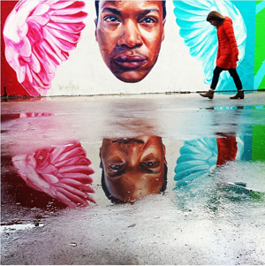
Source: Joshua Lott; Carlos Copertone

7. Use leading lines.
In some photos, there's a line that draws the viewer's eye toward a certain part of the frame. Those are called leading lines. They can be straight or circulinear -- think staircases, building facades, train tracks, roads, or even a path through the woods.
Leading lines are great for creating a sense of depth in an image, and can make your photo look purposefully designed -- even if you just happened to come upon a really cool shape by accident.
Source: Carlos Copertone; Paul Octavious

8. Look for symmetry.
Symmetry can be defined as "a vague sense of harmonious and beautiful proportion and balance." And pictures that contain symmetry can be incredibly pleasing to the eye -- it's also one of the simplest and most compelling ways to compose a photo.
And remember -- use those gridlines from tip #1 to line everything up perfectly.
Source: Eric Christian; Carlos Copertone

9. Keep an eye out for repetitive patterns.
Repetitive patterns are very pleasing to the eye -- they appear whenever strong graphic elements are repeated over and over again, like lines, geometric shapes, forms, and colors. These patterns can make a strong visual impact, and photographing something like a beautiful, tiled floor can be enough to create a striking image. Other times, it's more fun to keep an eye out for where they appear naturally or unintentionally, like with the congruent fire escapes on the left.
Source: Patrick Janelle
10. Avoid zooming in.
When you take a photo from a distance, it's tempting to zoom in on something specific you're trying to capture. But it's actually better not to zoom in -- doing so can make the photo appear grainy, blurry, or pixelated.
Instead, try to get closer to your subject or take the photo from a default distance, and crop it later on. That way, you won't compromise quality, and it's easier to play around or optimize a larger image. Also, using the landscape orientation instead of the portrait one will give you more room to wiggle.
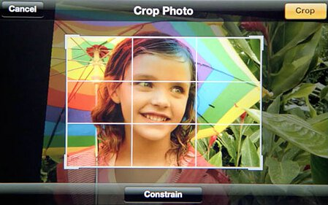

11. Capture small details.
You may have heard the phrase, "It's the little things." Sometimes, that also applies to photos. Close-up images that capture small, intricate, and delicate details can make for really compelling visual content. Keep an eye out for textures and patterns like peeling paint, a gravel road, or a tile tabletop.
Pro Tip: Use the "sharpen" or "HDR" tool in your favorite photo editing app to (conservatively) sharpen the details of your photo. You might also download the Camera+ app and use its Clarity filter, which is what The Wall Street Journal's Kevin Sintumuang calls the app's "secret sauce -- it adds pro-camera crispness to almost any shot."
Source: Paul Octavious; Eric Christian

12. Use natural light.
When indoors, even during the day, turn on all of the lights to eliminate as many shadows as possible.
Outside, take advantage of the sources of natural light you can find, even after dark. Always make sure to not take photos against the light, unless you can skillfully play with shadows, like in the second image below, or create a silhouette with other ambient sources of light, like traffic and surrounding buildings.
Once you've taken the photo, play with the "Exposure" tool in your favorite photo editing app to see if you can make the image slightly brighter, without making it too grainy.
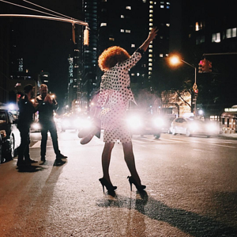
Source: Patrick Janelle; Paul Octavious

13. If you use flash, only do so during the day.
Sometimes, using your camera's flash can improve a photo -- but rarely does it do so at night. Because dark shots reveal a much sharper contrast against your phone's flash, it can make any flash look look invasive and uneven
In already well-lit spaces, however, a flash can help to soften some dark shadows behind or beneath your main subject. Obviously, never use a flash in front of reflective surfaces like mirrors and windows.
Check out the difference in the two mobile photos of a metal figurine, below. You can see the desk shadow is considerably softer in the flash-based photo on the right. The flash even brings out more details in the body of the subject. Consider this difference next time you're shooting product photography.

14. Consider buying a mobile tripod.
Although mobile devices make it easy to snap any photo on the go, there's never been an easy way to ensure the shot stays level and balanced when you shoot. Tripods are especially helpful when taking before and after pictures, making sure the images are taken from the exact same position, or professional selfies that don't include your extended arm.
Mobile tripods give you the freedom to mount your smartphone for quick hands-free shots without lugging any heavy equipment with you. Most mobile tripods are barely bigger than your mobile device, and can bend to any angle. Check out one of them from Joby, below, and learn how these miniature tripods can help enhance your mobile video experience below.
Source: Joby

15. Create abstracts.
Abstract photos are meant to capture the essence of an object, or a series of them, without revealing the entire landscape as a whole. In other words, they serve the purpose of creating unique, surprising images from ordinary subjects.
This look can be accomplished by cropping an abstract portion of an otherwise normal photo, or by taking close-up shots of objects that leave the viewer wondering -- in admiration, of course -- what the subject might be. And subjects with patterns or repetition are great candidates for abstract photography, like in the photo of sliced figs below.
Source: iPhone Photography School; Patrick Janelle

16. Take candids.
Posed photos can be great for the sake of memories -- happy moments with friends, family, or the occasional run-in with a celebrity. But sometimes, candid shots of people doing things, or people with people, can be far more interesting.
That's because candid photos are better able to effectively capture the emotion and essence of a moment. One of the best ways to capture this kind of shot is to just take as many photos as possible. You'll have more to choose from, and the best photos often happen when the "stars align," so to speak, in a single moment -- everyone's eyes are open, one person is tilting their head just so, and you finally got a shot of your chronically closed-lip friend smiling with his teeth.
Source: Patrick Janelle

17. Be non-conventional.
Composition is a huge part of what makes a photo great, but so is the photo's subject. Some of the most delightful and remarkable photos come out of cool, unique ideas-- that often means getting your photos to say something.
Try thinking outside of the box when it comes to what you're capturing -- your viewers could be pleasantly surprised by a cool or unexpected subject.
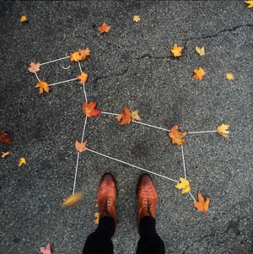
Source: Paul Octavious

18. Make 'em laugh.
Speaking of evoking emotion, sometimes the most memorable photos are the ones that make us giggle. The image below of an older woman wearing a brightly-colored shirt stating "Hi hater" is funny because it's unexpected -- and there's a part of us that admires her, too. The second image of the dog toy on a dinner plate pokes fun at classic Instagram food shots, but it's from a dog's perspective. If you can make your audience laugh, they're likely to enjoy your photo.
Source: Baddie Winkle; Jeremy Veach

19. Clean your phone's lens.
A smartphone camera might be more convenient to carry around than a full-fledged photographer's camera, but it comes at the cost of protection.
Your phone is usually in your pocket or your bag when you're out of the house. All the while, the device's camera lens is collecting all kinds of dust and lint. Be sure to clean this lens with a soft handkerchief before taking a photo. You might not be able to tell just how dirty the lens was until you start editing your picture, and making sure the lens is crystal clear before taking a shot can keep you from starting from scratch.

20. Don't be afraid to edit. But don't overdo it!
Composing and taking your smartphone photo is just the first step to making it visually compelling. Editing your photos is the next step -- and a very critical one, at that. Subtle filters can be a valuable photographic tool, particularly when you don't overdo them and you just use them to enhance clarity and colors.
There are many other great photo and video editing apps out there for mobile devices -- check out this post to see some of the best ones out there.

